Homework #7: Strings

Author: Konstantin Kostadinov

Objective: To understand and apply common string operations in C#, including concatenation, substring extraction, searching, comparison, and manipulation.
Part 1: Theory Questions
- What is string concatenation and how is it done in C#?
String concatenation is a non- commutative combination of two strings together, forming a new singular string.
For example, in C# code we have these two strings:
string A = “abc”;
string B = “cba”;

These two strings can be concatenated together, resulting in a new string “abccba” or “cbaabc”, depending on the order of the operation:
string C = A + B; //result of concatenation: “abccba”
string D = B + A; //result of concatenation: “cbaabc”

- What does the SubString() method do?
The substring method is used together with one or two whole numbers in order to take a specific part of a string, resulting in a brant new string:
string A = “Hello World!”;
string B = A.SubString(5); //B = “Hello”
string C = A.SubString(6, 6); // C = “World!”

The B string uses one number, which is the length of the string, which in this case is 5.
The C string uses two numbers, first one is the starting index (counting from 0), and the length of the taken string.

- How can you check if a string contains a specific word or character?
Using the Contains method on the string (which is case sensitive):
String A = “Hello World”;
Console.WriteLine(A.Contains(“Hello”); //Results in true

- What is the difference between == and .Equals() when comparing strings?
There is no difference when comparing strings:
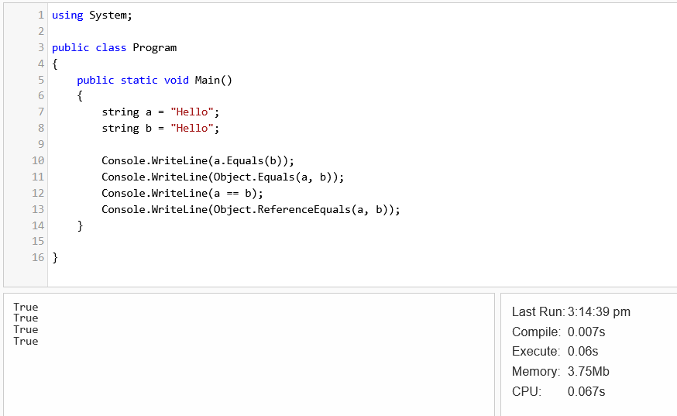
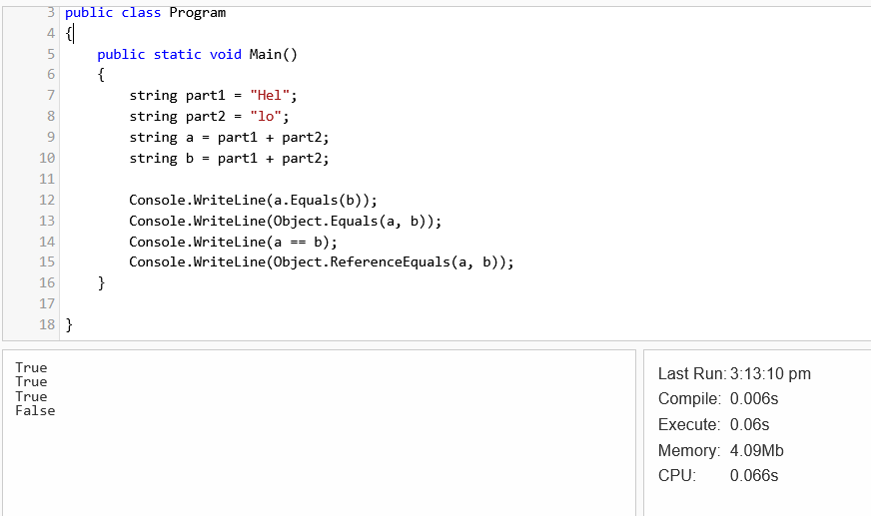
(Had to create the strings during runtime, as the compiler optimizes both variables to point to the same memory):

- What does IndexOf() return and how can it be used?
IndexOf method returns the index of a given item, from a set.
When it comes to strings, it returns the starting index of a string substring, otherwise it returns -1 if the substring is not found.

Part 2: Coding Exercises
(Can be found at https://github.com/Kalifer738/Endeva-Homework-Collection/tree/main)
- Write a method that extracts the domain from an email address.
Example:
string email = "randomName@example.com";
// Extract "example.com"

- Create a method that compares two strings for equality, ignoring case sensitivity.
Example:
string a = "Test";
string b = "test";
// Compare using Equals with case-insensitive option

- Create a method that checks if a provided string is palindrome or not.
Example:
string a = "abba";
string b = "abva";
IsStringPalindrome(a);
IsStringPalindrome(b);
// Console output:
'abba' is palindrome
' abva’ is not a palindrome

- Create a method that returns the count of occurrence of each letter present in a sentence (case insensitive, A == a).
Example:
string sentence = "I’m doing my best to learn C#";
.......
// Console output:
‘I’ has occurred 2 times
‘’’ has occurred 1 time
‘m’ has occurred 2 times
No duplications of letters in the console.

- Write a C# Sharp program to find the central character(s) in a given string. Return the middle character if the string length is odd and return two middle characters if the string length is even.
Expected Output :
Original string: Python
Middle character(s) of the said string: th
Original string: PHP
Middle character(s) of the said string: H
Original string: C#
Middle character(s) of the said string: C#

Bonus Challenge (Optional) Spy Code Name Generator
Task:
Write a method CreateCodeName(string firstName, string lastName).
Rules:
- Take the first 2 letters of the first name.
- Change the position of the 2 letters (the second becomes first and vice versa), example ‘ab’->’ba’
- Take the last 3 letters of the last name.
- Change the positions of the first and third letter, example: “sad” -> “das”.
- Concatenate both results from 2. and 4.
- Convert the result to uppercase.
- Bonus** Shift each letter 3 letters to the right, example:
“ANI” -> “DQL”
if it happens that the letter is X, Y or Z -> start from the beginning of the alphabet
“ZORO” -> “CRUR”

